Section 1: Multiple

Section 1: Multiple choices [1x15 = 15]
- Which Lewis structures are correct?

H H H

H O O H H N N H H N O

H

I II III

H

- C Cl

H

IV

  - I, II

  - II, IV

  - III, IV
  - I, III

- Which compound has the lowest boiling point?
 | H₃C |  |  | CH₃
CH₃CH₂CH₂CH₂CH₃ | CHCH₂CH₃ | H₃C |  | C |  |  | CH₃
a | H₃C |  |  | CH₃ |  |  |  | d
a | b |  |  |  | c |  |  | d
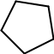

- Which is a conformer of pentane?

CH₃
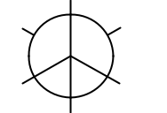

H | CH₃
H | H
CH₃

CH₃
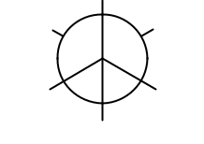

H | H
H₃C | CH₃
 | H

 | CH₃
H | CH₃
H | CH₂CH₃
 | H
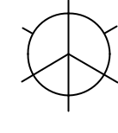

CH₃
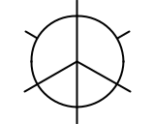

H H

H H

CH₂CH₃

a) b) c)

- What is the IUPAC name of the compound shown below?

d)

H
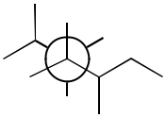

H

H

- 2-ethyl-4,4-dimethylhexane

- 5-ethyl-2,3,-dimethylhexane
- 3,5,6-trimethylheptane
- 2,3,5-trimethylheptane

CH₃

2

- Which of the following properties are not identical for constitutional isomers?

I. molecular formula
II. molecular weight
    - order of attachment of atoms IV. physical properties

  - I, IV

  - II, III

  - I, II

  - III, IV

- The most stable conformation of cis-1-isopropyl-4-methylcyclohexane is:

  - a chair with the isopropyl equatorial and the methyl axial

  - a chair with the isopropyl axial and the methyl equatorial
  - a boat with both the isopropyl and methyl substituents equatorial
  - a chair with both the isopropyl and methyl substituents equatorial

- Identify the conjugate bases in the following reactions.

 | CH₃NH₂ | + H3CCO2H
 | C₂H₅OH | +
 | C₂H₅OH | + |  |  |  | NaH
a) | CH₃OH | + |  | HCl
a) | II, III, VI
b) | I, IV, V
c) | I, III, V
d) | II, IV, VI

CH₃NH₃ + CH₃CO₂

I II

C₂H₅ONa + ^{H}2

III IV

CH₃OH₂ + Cl

V VI

- How many 1-3-diaxial interactions are present in 1-methylcyclohexane?

  - 0

  - 1

  - 3

  - 2

3

- Put the following molecules in the order of increasing pKa (from lowest to highest):

  - I<IV<II<III

  - II<IV<III<I

  - III<II<IV<I

  - IV<II<III<I

- What is the correct IUPAC name for the following compound?

  - cis-1-isopropyl-4-methylcyclohexane

  - trans-1-isopropyl-4-methylcyclohexane

  - trans-1-methyl-4-isopropylcyclohexane

  - cis-1-methyl-4-isopropylcyclohexane

- Which of the following are constitutional isomers of 1,3-dibromocyclohexane?

  - I, II, III, IV

  - II, III, IV

  - I, II

  - III, IV

- Molecule A is the enantiomer of molecule B. Molecule B is a stereoisomer of molecule C but NOT its mirror image. What is the relationship between A and C?

    - Same compound

    - Enantiomers
    - Diastereomers
    - Constitutional isomers
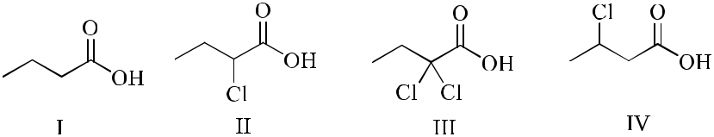
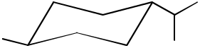
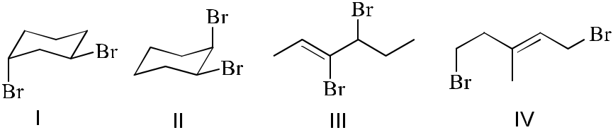

4

- Consider the following molecule:
CH(CH₃)₂
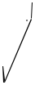

BrCH₃

Cl

_{H}CH₂CH₃
If Br and CH3 group switch their places, what would the relationship between the new molecule and the one above be?

- Constitutional isomers

- Same compound
- Enantiomers
- Diastereomers

- What is the role of diethyl ether in the following reaction?

CH₃CH₂OCH₂CH₃ + BF₃ 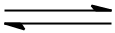 (CH₃CH₂)₂O BF₃ diethyl ether

  - Lewis acid

  - Lewis base
  - Brønsted acid
  - Brønsted base

- Which is the most stable structure of trans-1-ethyl-3-isopropylcyclohexane?
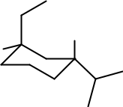
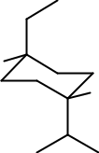

H | H | H | H
H |  |  | H | H
 |  |  |  | H | H
a | b |  | c |  | d
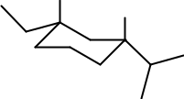
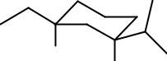

*****************************End of multiple choice******************************

- Draw all possible stereoisomers for the following compounds using dash and wedge bonds and provide the IUPAC names all the stereoisomers with absolute configurations. [10]
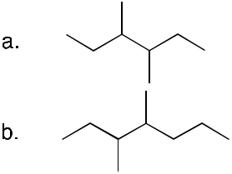

5

17. D a he Ne a ec i f c d 16a ( i g he chi a i ce e ca b ) i i

most stable form. [2]

- Write an acceptable IUPAC name of the following compounds. [10]
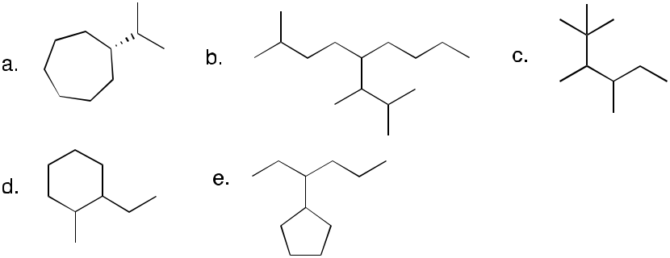

- Predict the product(s) of following reactions. Use the curved arrows to demonstrate the flow of electrons in the overall transformation. [4]
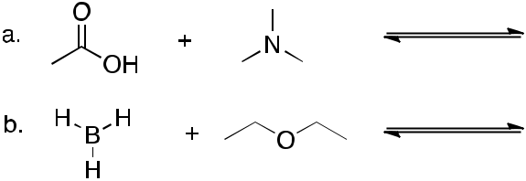

- Provide a reasonable explanation in your own words (no more than 5-6 sentences) for the following observations [4]:

- Trifluroacetic acid (TFA) is a stronger acid than acetic acid (AA).

TFA is a stronger acid than acetic acid since it has a high acid ionization constant compared to AA. The fluorine atoms are also highly electronegative hence exhibit electron withdrawing properties. This help in weakening the O – H bong making the conjugate base stable and increasing acidity.

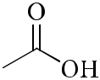
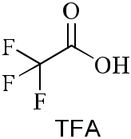
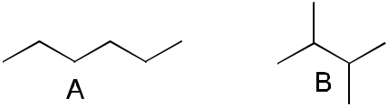

The boiling point of compound A is higher than that of compound B.
Compound A has a large surface area than compound B. The large surface area leads to greater dispersion hence increase in boiling point. Compound B is highly branched hence low surface area and consequently low boiling point.

- Draw all reasonable resonance contribution structures of the following species, use curved arrows to indicate electron movement. [5]
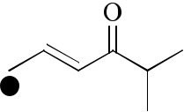

6

